SUPPLEMENTARY MATERIALS

Supplementary Table 1. CPT codes defined

CPT codes | Definition
22551 | Arthrodesis, anterior interbody, including disk space preparation, discectomy, osteophytectomy and decompression of spinal cord and/or nerve roots; cervical below C2
22554 | Arthrodesis, anterior interbody technique, including minimal distectomy to prepare interspace; cervical below C2
22612 | Arthrodesis, posterior or posterolateral technique, single level; lumbar
22630 | Arthrodesis, posterior interbody technique, including laminectomy and/or discectomy to prepare interspace, single interspace; lumbar
61312 | Craniectomy or craniotomy for evacuation of hematoma, supratentorial; extradural or subdural
61510 | Craniectomy, trephination, bone flap craniotomy; for excision of brain tumor, supratentorial, except meningioma
61512 | Craniectomy, trephination, bone flap craniotomy; for excision of brain tumor, supratentorial, for excision of meningioma, supratentorial
61548 | Hypophysectomy or excision of pituitary tumor, transnasal or transseptal approach, nonstereotactic
63020 | Laminectomy, with decompression of nerve root(s), including partial facetectomy, foraminotomy and/or excision of herniated intervertebral disk; 1 interspace, cervical
63030 | Laminectomy, with decompression of nerve root(s), including partial facetectomy, foraminotomy and/or excision of herniated intervertebral disk; 1 interspace, lumbar
63042 | Laminectomy, with decompression of nerve root(s), including partial facetectomy, foraminotomy and/or excision of herniated intervertebral disk; reexploration, single interspace; lumbar
63047 | Laminectomy, facetectomy and foraminectomy, single vertebral segment; lumbar
63075 | Discectomy, anterior, with decompression and of the spinal cord and/or never root(s), including osteophytectomy; cervical, single interspace

CPT, current procedure terminology.

Supplementary Table 2. ICD-9 codes defined

ICD-9 codes | Definition
191.1 | Malignant neoplasm of the frontal lobe
198.3 | Secondary malignant neoplasm of the brain and spinal cord
225.2 | Benign neoplasm of the cerebral meninges
437.3 | Cerebral aneurysm nonruptured
721.0 | Cervical spondylosis without myelopathy
721.1 | Cervical spondylosis with myelopathy
721.3 | Lumbosacral spondylosis without myelopathy
722.0 | Displacement of cervical intervertebral disc without myelopathy
722.10 | Displacement of lumbar intervertebral disc without myelopathy
722.52 | Degeneration of lumbar or lumbosacral intervertebral disc
722.71 | Intervertebral disk disorder with myelopathy cervical region
723.0 | Spinal stenosis in cervical region
724.02 | Spinal stenosis, lumbar region, without neurogenic claudication
738.4 | Acquired spondylolisthesis

ICD-9, Ninth Revision of International Classification of Disease.

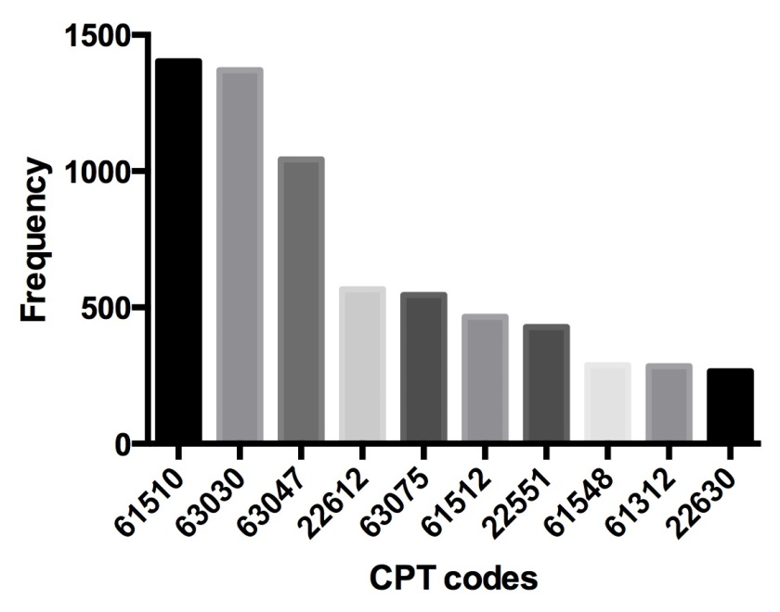
Supplementary Fig. 1. Ten most frequent current procedure terminology (CPT) codes in resident-assisted surgeries in the general cohort (n=13,654).

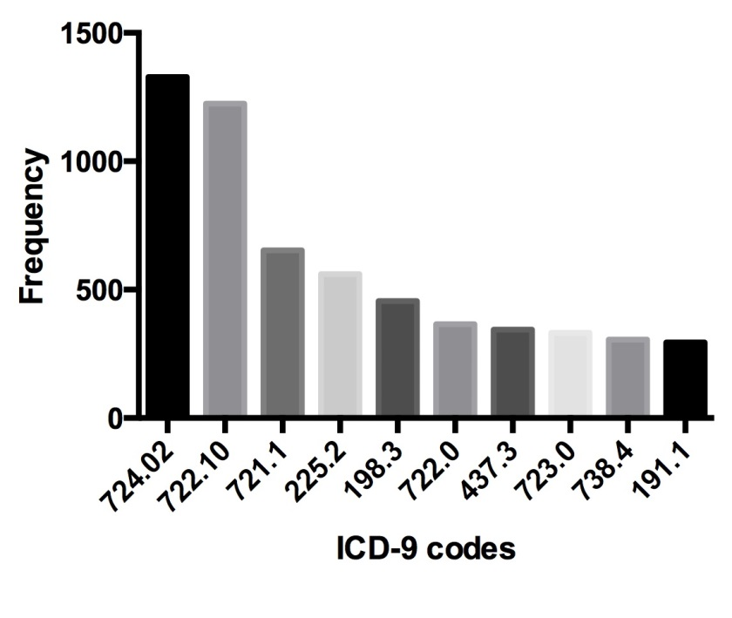
Supplementary Fig. 2. Ten most frequent ICD-9 codes in resident-assisted surgeries in the general cohort (n=13,654). ICD-9, Ninth Revision of the International Classification of Diseases.

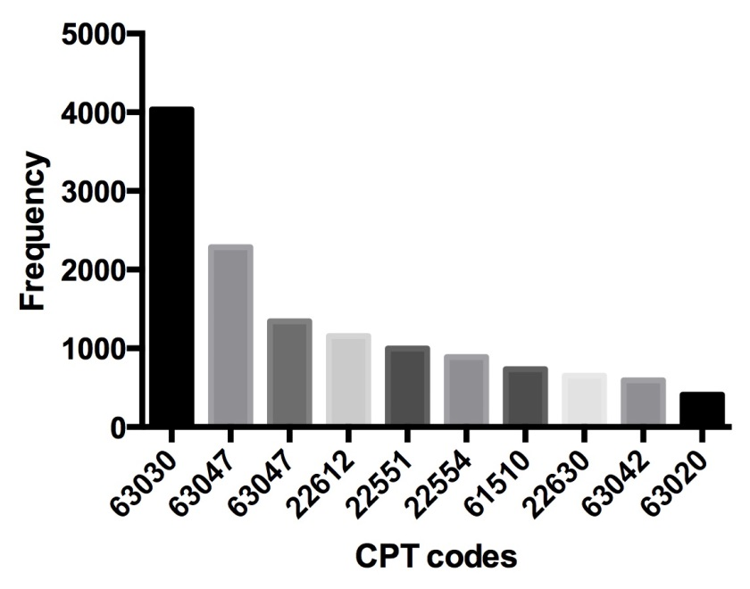
Supplementary Fig. 3. Ten most frequent current procedure terminology (CPT) codes in attending alone surgeries in the general cohort (n=20,323).

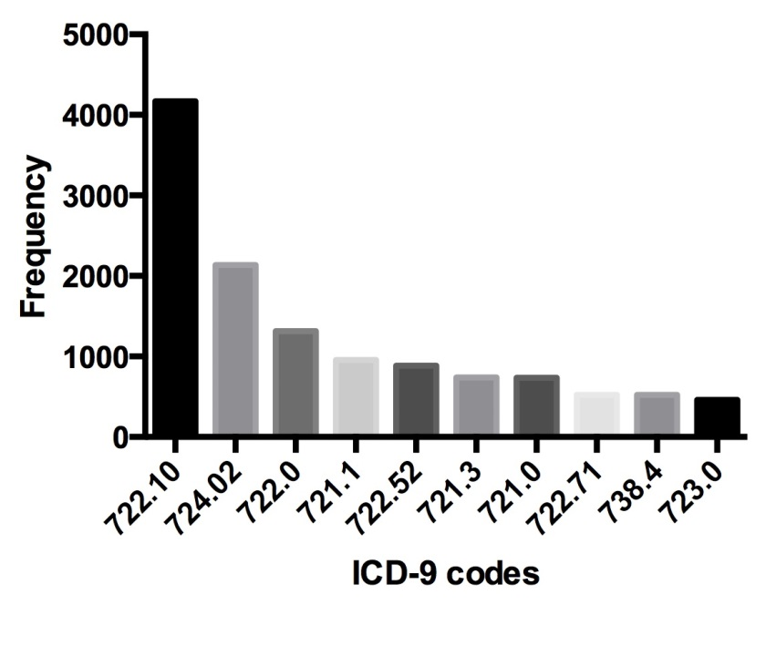
Supplementary Fig. 4. Ten most frequent ICD-9 codes in attending alone surgeries in the general cohort (n=20,323). ICD-9, Ninth Revision of the International Classification of Diseases.

